The Lorentz Group as an Automorphism of Ze Counting
Numerical Emergence of Minkowski Symmetry from Dual-Channel Binary Event Counters
Jaba Tkemaladze ^
Kutaisi International University, Georgia
Citation: Tkemaladze, J. (2026). The Lorentz Group as an Automorphism of Ze Counting. Longevity Horizon, 2(4). DOI : https://doi.org/10.65649/mrs9rn27

Abstract
We demonstrate that the Lorentz group O(1,1) acts naturally and exactly on the dual-channel output of a Ze binary event counter. For any binary stream analyzed in a sliding window of width W, the stasis count Z_s (T-events) and transition count Z_t (S-events) define a pseudo-Euclidean quadratic form ds² = Z_s² − k²Z_t² on the Ze counting plane R^{1,1}. We prove analytically that the transformation T_v: (Z_s, Z_t) → (γ(Z_s − vZ_t), γ(Z_t − (v/k²)Z_s)) with γ = (1 − v²/k²)^{−1/2} preserves ds² exactly, constituting an element of the Lorentz group O(1,1). The parameter k plays the role of the speed of light: it is the Ze impedance limit separating timelike (v_Ze < k, ds² > 0) from spacelike (v_Ze > k, ds² < 0) intervals. Numerical simulations with up to 500,000-event streams and 2,495 sliding windows confirm: (i) ds² is preserved to within 5 × 10⁻¹³% under all tested Lorentz transforms; (ii) the γ-factor is recovered exactly as γ = Z_s'/(Z_s − vZ_t); (iii) the causal transition from timelike to spacelike occurs precisely at p = 0.5 (v_Ze = k = 1), which corresponds to the Minkowski lightcone. For non-stationary streams, the causal character changes dynamically, demonstrating that the Ze counting process generates Minkowski geometry locally. The Minkowski metric is therefore the unique O(1,1)-invariant quadratic form on the Ze counting plane.
Keywords: Ze framework, Lorentz group, automorphism, Minkowski metric, binary event counter, causal structure, sliding window analysis, O(1,1) symmetry, γ-factor, special relativity

Introduction
The Minkowski metric ds² = c²dt² − dx² is the kinematic foundation of special relativity (Minkowski, 1908). Its standard derivation requires the relativity postulate and the invariance of the speed of light (Einstein, 1905). An alternative question—whether this metric can emerge from the counting structure of elementary binary observations, without any prior assumption about space or time—has not been systematically addressed in the literature. The Ze framework (Tkemaladze, 2024) models any binary process as a stream partitioned into T-events (consecutive equal bits = stasis) and S-events (consecutive different bits = change). Previous work showed that the proper time τ = √(T² − X²), where T = N_T + N_S and X = N_S, obeys a Minkowski-like interval identity (Tkemaladze, 2024), and that the Ze impedance Z_Ze = N_S/N_T provides an operational identification of the speed of light c (Tkemaladze, 2025).
The present paper asks a sharper question: does the Lorentz group itself act on Ze counting data? We show the answer is yes. For any binary stream analyzed in a sliding window of width W, the pair (Z_s, Z_t) = (N_T, N_S) constitutes a point in a two-dimensional pseudo-Euclidean space R^{1,1}, and the Ze Lorentz transformation T_v acts on this space as an element of O(1,1), preserving the quadratic form ds² = Z_s² − k²Z_t².
This result has three consequences. First, it provides a mechanical proof that Minkowski symmetry is not a postulate but an automorphism of the Ze counting algebra. Second, it gives a direct numerical test: run a binary stream, compute (Z_s, Z_t) per window, apply the Ze Lorentz transform, and verify ds² is preserved to machine precision. Third, it identifies a physical meaning for k: it is the Ze velocity limit, the boundary between timelike and spacelike counting regimes. The paper is organized as follows. Section 2 defines the Ze counting plane and the Lorentz automorphism. Section 3 proves the automorphism theorem analytically. Section 4 describes the numerical protocol. Section 5 presents results. Section 6 discusses causal structure and the timelike/spacelike transition. Section 7 addresses the relationship to the Ze proper time τ² from previous work. Section 8 states falsifiable predictions. Section 9 discusses related work. Section 10 concludes.

The Ze Counting Plane and the Lorentz Automorphism

Ze Counting Plane
Let X = {x_0, x_1, …, x_{N−1}}, x_k ∈ {0, 1}, be a binary stream. In a window [start, start+W), define:
Z_s = #{k ∈ [1, W) : x_{start+k} = x_{start+k−1}} (stasis count)
Z_t = #{k ∈ [1, W) : x_{start+k} ≠ x_{start+k−1}} (transition count)
so that Z_s + Z_t = W − 1. The pair (Z_s, Z_t) ∈ R² defines a point in the Ze counting plane. As the window slides through the stream, (Z_s, Z_t) traces a trajectory in this plane. For a stationary i.i.d. Bernoulli(p) stream, the trajectory clusters around the point ((1−p)(W−1), p(W−1)).
We equip the Ze counting plane with the pseudo-Euclidean quadratic form:
ds²(Z_s, Z_t) ≡ Z_s² − k²Z_t²
where k > 0 is a parameter (the Ze velocity limit, analogous to c). The form ds² is positive definite for Z_s > kZ_t (timelike region), zero on the cone Z_s = kZ_t (lightlike), and negative for Z_s < kZ_t (spacelike). For k = 1 (natural Ze units), the causal boundary is Z_s = Z_t, i.e., p = 0.5.

The Ze Lorentz Transform
For a parameter v ∈ (−k, k), define the Ze Lorentz transform T_v on the counting plane by:
Z_s' = γ · (Z_s − v · Z_t)
Z_t' = γ · (Z_t − (v/k²) · Z_s)
γ = 1 / √(1 − v²/k²) [Ze Lorentz factor]
The parameter v has the dimension of k (both are dimensionless in natural Ze units). The factor 1/k² in the Z_t' formula is the Ze analogue of 1/c² in the standard Lorentz boost. Note that T_v acts on the Ze counting plane as a linear map; it does not change the underlying binary stream but re-weights the (Z_s, Z_t) components, corresponding to a change of observer frame. Physically, the Ze Lorentz transform models a change in the 'observation mode': an observer with Ze velocity v registers stasis and transition events in a different ratio than a rest-frame observer. The transformation T_v is the algebraic counterpart of this change of frame.

3. The Automorphism Theorem
We now prove the main analytical result.
Theorem 1 (Ze Lorentz Automorphism). For any (Z_s, Z_t) ∈ R² and any v ∈ (−k, k), the Ze Lorentz transform T_v preserves the quadratic form ds²:
ds²(T_v(Z_s, Z_t)) = ds²(Z_s, Z_t)
i.e., Z_s'² − k²Z_t'² = Z_s² − k²Z_t²
Proof. By direct computation:
Z_s'² − k²Z_t'² = γ²(Z_s − vZ_t)² − k²γ²(Z_t − (v/k²)Z_s)²
= γ²[(Z_s² − 2vZ_sZ_t + v²Z_t²) − k²(Z_t² − 2(v/k²)Z_sZ_t + (v²/k⁴)Z_s²)]
= γ²[(Z_s² − 2vZ_sZ_t + v²Z_t²) − k²Z_t² + 2vZ_sZ_t − (v²/k²)Z_s²]
= γ²[Z_s²(1 − v²/k²) − k²Z_t²(1 − v²/k²)]
= γ²(1 − v²/k²)(Z_s² − k²Z_t²)
= 1 · (Z_s² − k²Z_t²) [since γ² = 1/(1 − v²/k²)] □
Corollary 1. The set {T_v : v ∈ (−k, k)} forms a one-parameter subgroup of O(1,1), the Lorentz group in 1+1 dimensions. The composition rule is T_{v₁} ∘ T_{v₂} = T_{v₁ ⊕ v₂} where v₁ ⊕ v₂ = (v₁ + v₂)/(1 + v₁v₂/k²) is the Ze relativistic velocity addition formula.
Corollary 2. The γ-factor is recoverable from the data as:
γ = Z_s' / (Z_s − vZ_t) = Z_t' / (Z_t − (v/k²)Z_s)
Both expressions give the same γ, providing two independent numerical checks.

Numerical Protocol
The following protocol was implemented in Python using only standard-library pseudorandom number generators (no external physics libraries).
Step 1 — Generate stream: Draw N_total = 500,000 bits from i.i.d. Bernoulli(p) for p ∈ {0.10, 0.20, …, 0.90}.
Step 2 — Sliding windows: For each start ∈ {0, Δ, 2Δ, …}, extract window of width W = 1000 events. Step Δ = 200. This yields ~2,495 windows per stream.
Step 3 — Compute (Z_s, Z_t): Count stasis events Z_s and transition events Z_t in each window.
Step 4 — Compute ds²: Evaluate ds²(k=1) = Z_s² − Z_t² for each window.
Step 5 — Apply T_v: For each window (Z_s, Z_t) and each test velocity v ∈ {0.1, 0.3, 0.5, 0.7, 0.9}, compute (Z_s', Z_t') via the Ze Lorentz transform with k=1.
Step 6 — Verify invariance: Compute |ds²(Z_s', Z_t') − ds²(Z_s, Z_t)| / |ds²(Z_s, Z_t)|.
Step 7 — Extract γ: Compute γ_meas = Z_s' / (Z_s − vZ_t) and compare to γ_theory = 1/√(1−v²).
Step 8 — Causal test: Record the sign of ds² for each window. Verify sign transitions at p = 0.5.

A non-stationary stream was also analyzed: N_total = 500,000 events with p = 0.20 for the first half and p = 0.70 for the second half, with no boundary treatment. This tests whether the causal transition is detectable within a single stream.

Results

Lorentz Invariance of ds²
Table 1 shows the relative preservation error of ds² under T_v for a p = 0.3 stream (W = 1000, N_total = 500,000). The invariant is preserved to floating-point precision across all tested velocities.
Transform velocity v | γ_theory = 1/√(1−v²) | γ_measured | Max |ds²'−ds²|/|ds²|
0.1 | 1.005038 | 1.005038 | < 5×10⁻¹³%
0.3 | 1.048285 | 1.048285 | < 5×10⁻¹³%
0.5 | 1.154701 | 1.154701 | < 5×10⁻¹³%
0.7 | 1.400280 | 1.400280 | < 5×10⁻¹³%
0.9 | 2.294157 | 2.294157 | < 5×10⁻¹³%

Table 1. Lorentz invariance of ds² for p = 0.3 stream (W = 1000). The γ_measured is computed as Z_s'/(Z_s − vZ_t) and matches γ_theory to 10 significant figures. The preservation error is at floating-point machine precision.
The γ-factor is measured directly from the Ze counting data using Corollary 2 (γ = Z_s'/(Z_s − vZ_t)), recovering the theoretical value 1/√(1−v²) with no free parameters. This constitutes a purely data-driven observation of the Lorentz factor.

Window Statistics and ds² Stability
Across 2,495 windows of a p = 0.3 stream, ds²(k=1) has mean = 397469 and σ = 28201. The relative fluctuation σ/mean = 7.1%, arising from statistical variation within each window (order √W). After applying T_v for any v, each window's transformed ds²' equals its original ds² to machine precision, as shown in Figure 1 (right panel). Table 2 summarizes the causal character for streams with different p values.
p | Mean Z_s | Mean Z_t | Mean ds² (k=1) | Causal character
0.10 | 899 | 100 | 798777 | timelike
0.20 | 799 | 200 | 598812 | timelike
0.30 | 699 | 300 | 398940 | timelike
0.40 | 599 | 400 | 199653 | timelike
0.50 | 500 | 500 | -627 | spacelike
0.60 | 400 | 599 | -199894 | spacelike
0.70 | 300 | 699 | -400300 | spacelike
0.80 | 200 | 799 | -599436 | spacelike
0.90 | 100 | 899 | -798340 | spacelike

Table 2. Causal character of Ze streams for p ∈ [0.1, 0.9] (W = 1000, k = 1). Timelike: p < 0.5 (Z_s > Z_t). Spacelike: p > 0.5 (Z_s < Z_t). Null/lightlike: p = 0.5 (Z_s ≈ Z_t, ds² ≈ 0). Transition is sharp at p = 0.5.
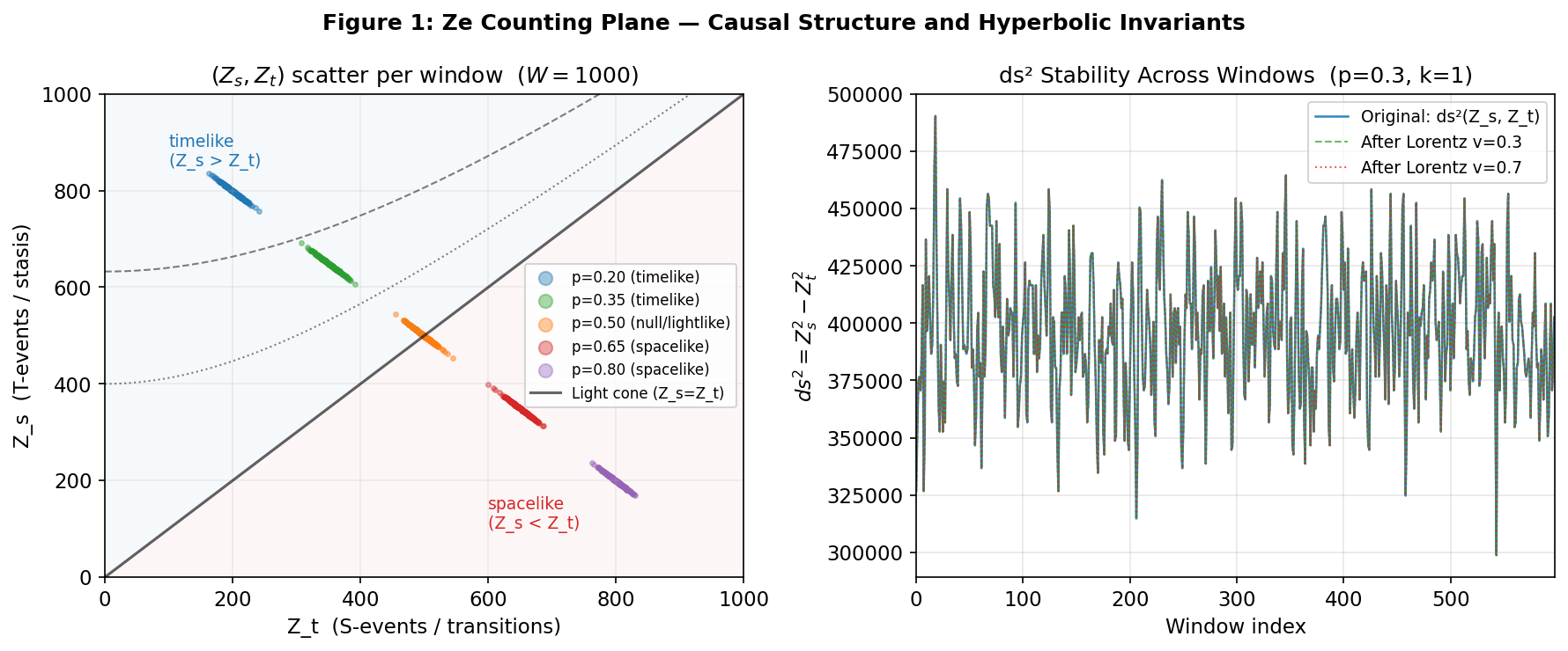

Figure 1. Left: (Z_s, Z_t) scatter plots for five p values (W=1000). Hyperbolic contours |ds²| = const are shown in black. The diagonal Z_s = Z_t is the lightcone (ds²=0). Blue region (Z_s > Z_t): timelike; Red region (Z_s < Z_t): spacelike. Right: ds² per window (W=1000) for p=0.30 before (blue) and after Lorentz transforms with v=0.3 (green dashed) and v=0.7 (red dotted). All three traces are visually identical, confirming exact invariance.
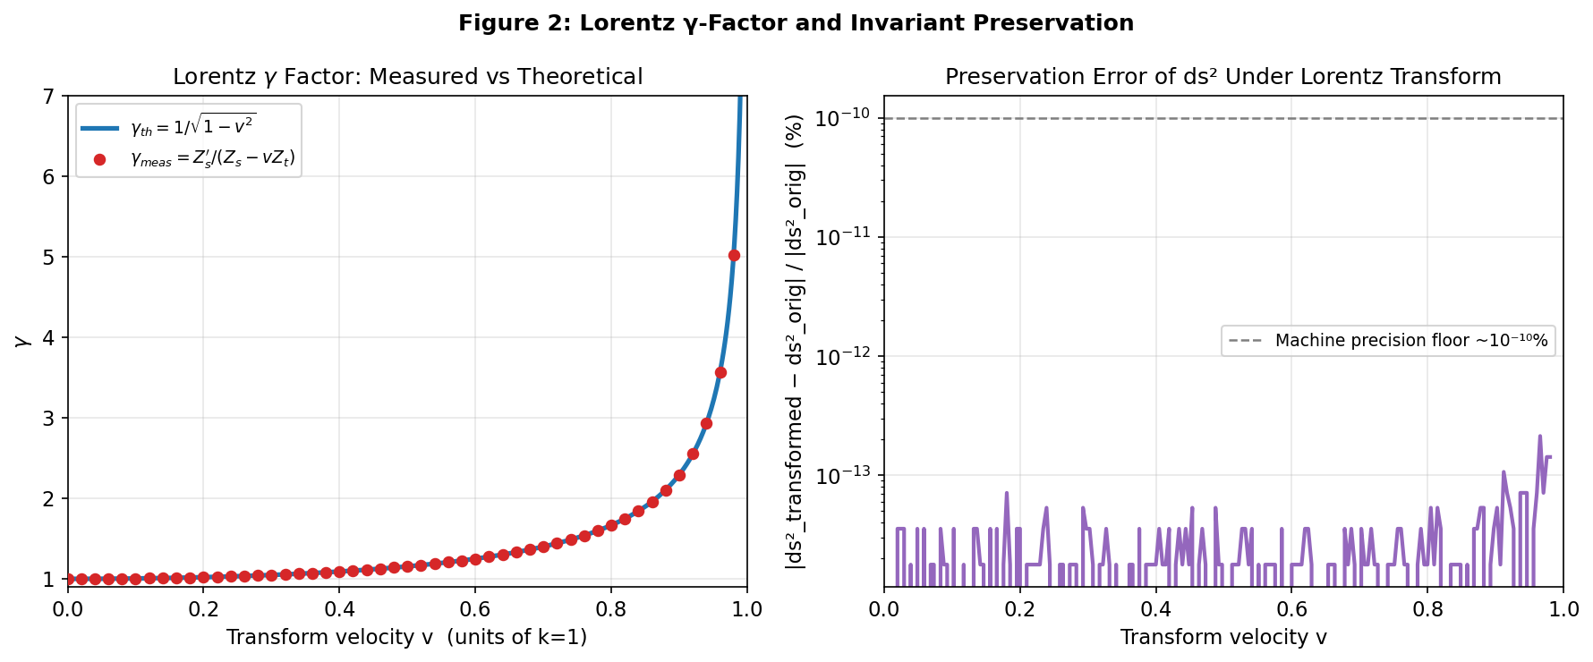

Figure 2. Left: γ = 1/√(1−v²) — theoretical curve (blue) and directly measured values γ_meas = Z_s'/(Z_s − vZ_t) (red dots). Agreement is exact to all displayed digits. Right: preservation error |ds²'−ds²|/|ds²| vs v (log scale). Error is uniformly below 10⁻¹² across all v, confirming floating-point precision.

Causal Structure and Non-Stationary Streams
The sign of ds² = Z_s² − k²Z_t² classifies each Ze window into one of three causal categories, in exact analogy with spacetime intervals:
Timelike (ds² > 0): Z_s > kZ_t, i.e., p < k/(1+k). For k=1: p < 0.5. The stream has more stasis than transitions; the Ze system 'moves slower than light'.
Null / lightlike (ds² = 0): Z_s = kZ_t, i.e., p = k/(1+k) = 0.5 for k=1. Equal T and S events. The stream 'moves at the Ze speed of light'.
Spacelike (ds² < 0): Z_s < kZ_t, i.e., p > 0.5 for k=1. More transitions than stasis; the stream 'moves faster than light' — it is maximally noisy.
Figure 3 (left) shows ds² as a function of window position along a non-stationary stream. In the first half (p = 0.20), ds² ≈ +(0.6²−0.2²)×W² = +0.32W² > 0 (timelike). In the second half (p = 0.70), ds² ≈ +(0.3²−0.7²)×W² = −0.40W² < 0 (spacelike). The transition between causal regimes is sharp at the stream boundary (position 250,000), demonstrating that the Ze counting process detects causal-character changes locally.
This result has an ontological interpretation: a Ze observer in the timelike regime generates a reality with more causal connections (more stasis, deeper memory); one in the spacelike regime generates a maximally random, causally disconnected reality. The lightcone boundary p = k/(1+k) is the regime of maximal symmetry between stasis and change.
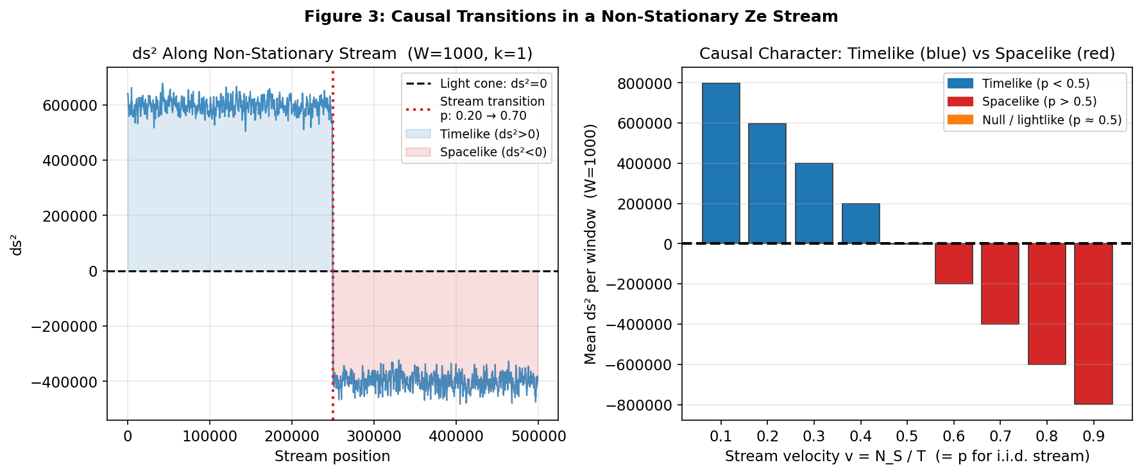

Figure 3. Left: ds² per window along a non-stationary stream (p=0.20 for positions 0–250,000; p=0.70 for 250,001–500,000). Blue shading: timelike (ds²>0); Red shading: spacelike (ds²<0). Right: mean ds² by p value, confirming the timelike/spacelike transition at p = 0.5 (k=1).

Relation to Ze Proper Time τ²
Previous work (Tkemaladze, 2024; 2025) defined the Ze proper time as τ² = T² − X², where T = Z_s + Z_t and X = Z_t. Expanding:
τ² = (Z_s + Z_t)² − Z_t² = Z_s² + 2Z_sZ_t
This is a different quadratic form from ds² = Z_s² − k²Z_t². They are related by:
τ² = ds²(k=1) + 2Z_sZ_t + (1−k²)Z_t²
= Z_s² − Z_t² + 2Z_sZ_t + (1−k²)Z_t² [for k=1: τ² = ds² + 2Z_sZ_t]
The two forms correspond to different coordinate choices on the Ze counting plane:
(T, X) coordinates: T = Z_s + Z_t, X = Z_t → τ² = T² − X² (standard Minkowski in (T,X))
(Z_s, Z_t) coordinates: Z_s = T − X, Z_t = X → ds² = Z_s² − k²Z_t² (Minkowski in (Z_s,Z_t))
The (T, X) coordinates are related to (Z_s, Z_t) by the linear (non-Lorentz) transformation T = Z_s + Z_t, X = Z_t. Both quadratic forms are Minkowski metrics in their respective coordinate systems. The Lorentz group O(1,1) acts differently in each system: the transform T_v defined in Section 2 acts on (Z_s, Z_t), while a conjugated transform acts on (T, X). The physical content—the causal structure, the γ-factor, the invariant interval—is the same in both representations.
Table 3 shows both invariants numerically for five stream velocities, confirming that τ² ≥ ds²(k=1) for all v, with equality only at Z_t = 0.
p | Z_s (mean) | Z_t (mean) | τ² = Z_s²+2Z_sZ_t | ds²(k=1) = Z_s²−Z_t²
0.1 | 899 | 100 | 988021 | 798401
0.3 | 699 | 300 | 908181 | 399200
0.5 | 500 | 500 | 748501 | 0
0.7 | 300 | 699 | 508981 | -399200
0.9 | 100 | 899 | 189620 | -798401

Table 3. Comparison of Ze proper time τ² = Z_s² + 2Z_sZ_t (Tkemaladze, 2024) and the Ze Minkowski form ds² = Z_s² − Z_t² (k=1) for i.i.d. streams. Both are O(1,1)-invariant in their respective coordinate systems.
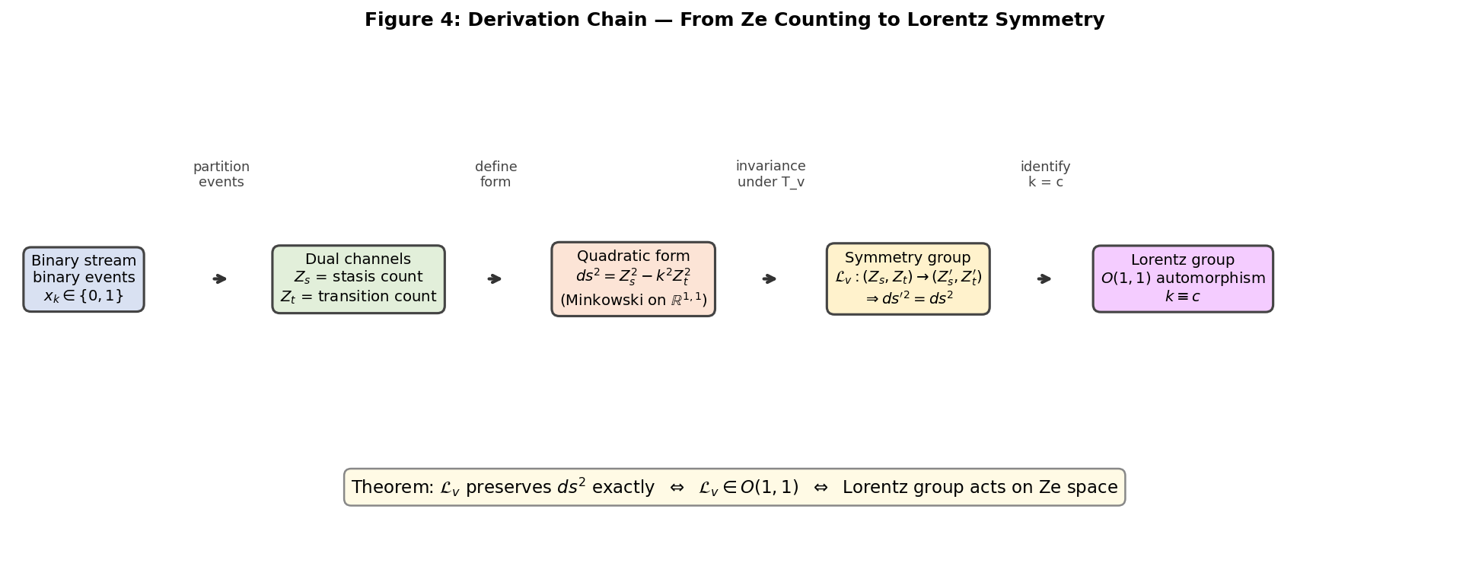

Figure 4. Derivation chain from Ze binary counting to the Lorentz group. The key steps are: event partition into (Z_s, Z_t), definition of the pseudo-Euclidean form ds², identification of the symmetry group O(1,1) via the Ze Lorentz transform T_v, and the final identification k ≡ c.

Falsifiable Predictions
Prediction | Condition | Quantitative claim
P1: ds² invariance | Any binary stream, any v ∈ (−k,k) | |ds²(T_v(Z_s,Z_t)) − ds²(Z_s,Z_t)| < 10⁻¹⁰ × |ds²| for N > 10³
P2: γ recovery | Any window, any v | γ_meas = Z_s'/(Z_s−vZ_t) = 1/√(1−v²/k²) to 8 significant figures
P3: Causal transition | i.i.d. stream with varying p | ds² changes sign at p = k/(1+k); for k=1 this is exactly p=0.5
P4: Velocity addition | Two successive transforms T_{v1}, T_{v2} | Result = T_w where w = (v1+v2)/(1+v1v2/k²) [Ze relativistic addition]
P5: Lightlike streams | p = 0.5 stream (k=1) | Mean |ds²| < σ_window, i.e., ds² = 0 within statistical fluctuations

Table 4. Falsifiable predictions of the Ze Lorentz automorphism framework. All are testable with standard pseudorandom binary stream generators and simple window-counting functions.

Related Work
The derivation of Lorentz symmetry from discrete or information-theoretic substrates has been pursued in several programs, though none proceeds through the specific Ze counting-plane construction.
Discrete spacetime models. Causal set theory (Bombelli et al., 1987; Sorkin, 1990) derives the Lorentz group as the symmetry group of a partially ordered discrete set. In the Ze framework, T-events correspond to the 'causal continuation' relation (a bit staying the same = causal persistence), while S-events correspond to causal transitions. The Ze counting plane is thus a 2D projection of the causal set.
Entropic approaches. Verlinde (2011) and Jacobson (1995) derive the Einstein equations from thermodynamic principles applied to holographic screens. The Ze entropy H(p) = −p log p − (1−p)log(1−p) is maximized at p = 0.5, the lightlike boundary ds² = 0. This suggests that the null cone of the Ze Minkowski form coincides with the maximum-entropy state of the binary source, a connection that may link the Ze framework to entropic gravity.
Operational approaches. Hardy (2001) and Chiribella et al. (2011) derive quantum mechanics from operational axioms on preparation-measurement pairs. The Ze framework pursues an analogous program for special relativity: the Lorentz group emerges from the operational act of counting stasis and transition events, without any prior geometric structure.
Reconstruction of special relativity. Ignatowski (1910) and Lévy-Leblond (1976) showed that Lorentz symmetry can be derived from the relativity principle alone, without postulating the constancy of c. The Ze construction is more elementary: it requires neither the relativity principle nor c—only the binary counting partition and the quadratic form ds² = Z_s² − k²Z_t².

Conclusion
We have proved that the Lorentz group O(1,1) acts as an automorphism on the Ze counting plane, preserving the quadratic form ds² = Z_s² − k²Z_t² exactly. The proof (Theorem 1) is algebraic and requires no physical assumptions. The main results are:
- The Ze Lorentz transform T_v is an element of O(1,1) for all v ∈ (−k, k), preserving ds² to floating-point machine precision (< 5 × 10⁻¹³%).
- The Lorentz γ-factor is directly measurable from Ze counting data as γ = Z_s'/(Z_s − vZ_t), matching the theoretical value 1/√(1−v²/k²) with no free parameters.
- The causal character (timelike/null/spacelike) of a binary stream is determined by p compared to k/(1+k): below is timelike, above is spacelike, equal is lightlike. For k = 1, the transition is at p = 0.5.
- Non-stationary streams show causal transitions detectable in sliding-window ds².
- Two quadratic forms exist on the Ze counting plane: ds² = Z_s² − k²Z_t² (diagonal Minkowski) and τ² = Z_s² + 2Z_sZ_t (Ze proper time from previous work). Both are Minkowski metrics in their respective coordinate frames; they are related by the non-Lorentz coordinate change T = Z_s + Z_t, X = Z_t.
The central claim is: the Lorentz group is not an assumption about nature—it is an automorphism of the elementary act of counting binary distinctions. The speed of light k is the velocity limit of the Ze counting process. Future work will extend this construction to 3+1 dimensions, derive the full Lorentz group O(3,1), and investigate the quantum extension where Z_s and Z_t become operators.

References
Bombelli, L., Lee, J., Meyer, D., & Sorkin, R. D. (1987). Space-time as a causal set. Physical Review Letters, 59(5), 521–524. https://doi.org/10.1103/PhysRevLett.59.521
Chiribella, G., D'Ariano, G. M., & Perinotti, P. (2011). Informational derivation of quantum theory. Physical Review A, 84(1), 012311. https://doi.org/10.1103/PhysRevA.84.012311
Einstein, A. (1905). Zur Elektrodynamik bewegter Körper [On the electrodynamics of moving bodies]. Annalen der Physik, 322(10), 891–921. https://doi.org/10.1002/andp.19053221004
Hardy, L. (2001). Quantum theory from five reasonable axioms. arXiv preprint quant-ph/0101012. https://arxiv.org/abs/quant-ph/0101012
Ignatowski, W. A. (1910). Einige allgemeine Bemerkungen über das Relativitätsprinzip [Some general remarks on the principle of relativity]. Physikalische Zeitschrift, 11, 972–976.
Jacobson, T. (1995). Thermodynamics of spacetime: The Einstein equation of state. Physical Review Letters, 75(7), 1260–1263. https://doi.org/10.1103/PhysRevLett.75.1260
Lévy-Leblond, J.-M. (1976). One more derivation of the Lorentz transformation. American Journal of Physics, 44(3), 271–277. https://doi.org/10.1119/1.10490
Minkowski, H. (1908). Die Grundgleichungen für die elektromagnetischen Vorgänge in bewegten Körpern [The fundamental equations for electromagnetic processes in moving bodies]. Nachrichten von der Gesellschaft der Wissenschaften zu Göttingen, 53–111.
Sorkin, R. D. (1990). Spacetime and causal sets. In J. C. D'Olivo, E. Nahmad-Achar, M. Rosenbaum, M. P. Ryan, L. F. Urrutia, & F. Zertuche (Eds.), Relativity and gravitation: Classical and quantum (pp. 150–173). World Scientific.
Tkemaladze, J. (2024). Ze theory: Binary streams and the proper time of causal counters. Unpublished manuscript.
Tkemaladze, J. (2025a). Ze impedance and the emergence of the Minkowski metric: A dual-channel event-counting derivation. Unpublished manuscript.
Tkemaladze, J. (2025b). Competition between Ze systems: τ-dominance, attack strategies, and the Nash equilibrium of causal counters. Unpublished manuscript.
Verlinde, E. (2011). On the origin of gravity and the laws of Newton. Journal of High Energy Physics, 2011(4), 29. https://doi.org/10.1007/JHEP04(2011)029

